2018 Questions for Race Walk Judges progressing to Level 2
- What are the two parts of the main rule of race walking?
- What do these paddles mean?
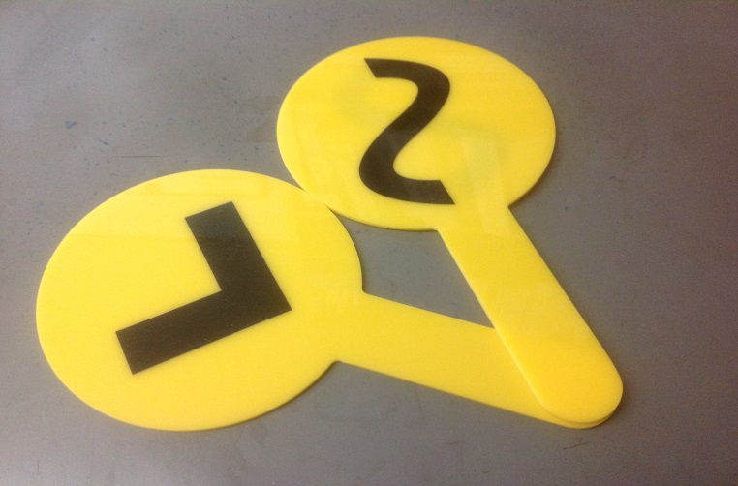
- When would these paddles be shown to the competitors?
- Can a judge show the same paddle more than once to the same competitor?
- Why is a red card completed and what happens to it once that has been done?
- What is a red paddle used for and who would use it?
- Where is the best position from which to judge at a track event?
- Where is the best position from which to judge at a road race?
- Where are competitors most likely to break the rules of race walking? Give at least two examples.

