LEVEL 4 QUESTIONS ON WA, UKA AND WPA RULES – PHOTO FINISH (2022)

• In order to answer these questions, you will require UKA/WA and WPA rulebooks. Please give the relevant rule numbers in your answers along with your explanations. You must demonstrate that you understand and can apply the rules – and not simply quote them.
• The guidance previously given in “The Referee” is now incorporated into the rulebook and you should find this helpful. It is recommended, though, that you still look at other relevant documents such as the IPFJ guidelines which can be found in the Library area of the World Athletics Website. If such documents are used, please state your source in your answers.
• Please read the current Guidelines for Applications for Level 4, which can be found on the UKA website, carefully and follow the instructions given. The latest date for answers to be submitted to your TRNG Officials’ Secretary is September 1st. Early submission is advised.

1. (a) Why do we carry out a zero-control test (ZCT), who is responsible for it and how should this be completed?
(b) What are the parameters for an acceptable test and what do the results mean?
(c) What are the implications if ZCT shows a consistent 0.03 secs difference between the recorded flash and the timing start?
b) The flash of the gun on the picture should be read in 1/10000s of a second to check that the photo finish system has been started within the limit of 0.001s (WA Rule TR19.13.2).

2. The transducer fails to produce a start signal. Why is it still appropriate to capture an image of the finish?

3. Describe how you would deal with a distance race involving a significant amount of lapping.

4. a) How would an operator notice that a camera is no longer properly on line?
b) As CPF, what would you do about it and what implications are there to the competition?

5. A technician has set up the system for you, but as Chief Photo Finish Judge you are required to ensure that the equipment is fully operational.
a) List the checks you should make before the meeting.
b) What are tap tests? When and why do we do them?

6. In an 800m wheelchair race there is a crash just prior to the finish line with wheelchairs sliding or flying across the finish line. Why should you examine the photo finish picture carefully?
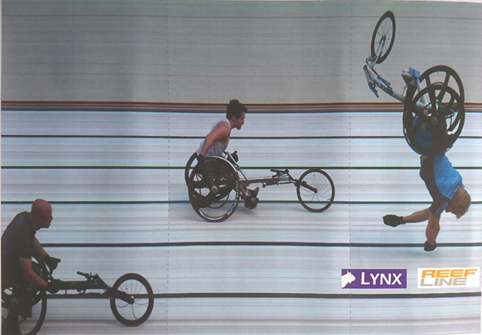

7. The next scheduled race is the 4x400m. You are on the button and have been asked to capture every change over.
a) Why have you been asked to do this?
b) Are there any pitfalls in this?
c) What other information might it be useful for the reader to know and why?

8. A system failure occurs on the 2nd heat of 3 in a Combined Events sprint race (Men – 100m) which means that only hand times are available for that race. What is the impact on the other heats and on the Combined Events competition?

9. You are Chief at an outdoor national championship, run under WA rules and which has both an inside and outside camera.
a) Under normal circumstances which camera should be used to declare the results?
b) What use should you make of the other camera?
c) Explain how you check the alignment of the two cameras.
d) What effect would any differences have on the results and the way you use the second camera?

10. An athlete falls just before the finish line and slides across feet first coming to rest across the finish line.
a) How would identify this athlete’s finishing position and time?
b) An irate parent approaches you demanding that the result be changed as they have video evidence that their child crossed the line before the person lying on the finish line. What action would you take?

11. You are Chief PF at an Open Meeting. The PF equipment you are using has an automatic wind gauge i.e. one where readings are directly obtained by the PF software. The meeting contains a series of 200m races. Describe the challenges you are faced with obtaining accurate wind readings for these races and list the factors that come into play in making a decision about how to approach this.

12. You have been appointed to be CPF at a major UK able-bodied meeting during which para-athletics is being showcased. There will be a range of races across the para-classifications. One of these races will be a relay. Regarding the para-races:
a) what should you check is in place?
b) what should you remind your team about?
c) With whom should you liaise and why?
Identify any specific considerations that you will need to make and responsibilities you have for races involving:
• Visually impaired athletes
• Wheelchair athletes
• Frame Runners

13. You are Chief PF and have been given two radios – one is on the main channel and the other is on a dedicated channel for communicating with Photo Finish. Shortly after a race has started, you are called on the PF channel.
(a) Who might be calling you?
(b) What information might the person be relaying to you?
(c) What action do you take?
(d) Why is it important that information is relayed to PF quickly and clearly?
(e) If the meeting were being held under WA as opposed to UKA rules, what additional implications would this have?

14. As part of your role, you are keeping an eye on the qualifiers from heats to SF /Finals etc. The results from some 100m races are below. (The number in brackets represents the athlete’s bib number.)

 | Heat 1 | Heat 2 | Heat 3 | Heat 4 | Heat 5
1st | (62) 11.77 | (76) 11.75 | (61) 11.80 | (114) 11.79 | (73) 11.76
2nd | (113) 11.81 | (104) 11.79 | (85) 11.82 | (92) 11.85 | (90) 11.81
3rd | (99) 11.85 | (129) 11.81 | (83) 11.84 | (69) 11.86 | (59) 11.86
4th | (137) 11.87 | (91) 11.85 | (100) 11.85 | (121) 11.88 | (77) 11.87
5th | (111) 11.89 | (78) 11.87 | (97) 11.85 | (91) 11.92 | (109) 11.89
6th | (54) 11.90 | (66) 11.87 | (74) 11.90 | (79) 11.95 | (71) 11.91
7th | (125) 11.92 | (127) DNF | (103) 11.91 | (124) DQ

(a) What is the qualifying and who should be put through to the next round?
(b) If athletes 100 and 97 had dead-heated who would qualify for the next round?
(c) Originally, 42 athletes had entered, but not everyone registered on the day. If all 42 had appeared, would the qualification procedure be any different?
(d) A technical failure led to nothing being captured for the 4th heat How will you deal with this? What practical considerations need to be considered? Does the situation change under WA rules? How would any of this change, if the technical failure resulting in a start not being received, but a picture was successfully captured?

