LEVEL 4 QUESTIONS FOR STARTERS AND STARTERS’ ASSISTANTS (2022)
KNOWLEDGE AND UNDERSTANDING OF THE ROLE
WA, UKA AND WPA RULES AND INTERPRETATIONS
- In order to answer these questions, you will require UKA/ WA and WPA rulebooks. Please give the relevant rule numbers in your answers along with your explanations. You must demonstrate that you understand and can apply the rules – rather than quoting rules back verbatim.

- You may find the WA Starters Guidelines a useful source of additional information.

- Please read the current Guidelines for Presenting Applications for Level 4, which can be found on the UKA website, carefully and follow the instructions given. The latest date for answers to be submitted to your TRNG Officials’ Secretary is September 1st. Early submission is advised to allow, upgrades, if necessary.

You can use any resources available to you including UKA, WPA and WA rule books and WA Starting Guidelines which can be downloaded from their website. Ensure that you only refer to current issues

This is a common paper intended for those candidates who are specialist Starters’ Assistants and those who are also Starters.

Note carefully:

ALL Candidates MUST answer questions 1 through 7

If you are a specialist Starters’ Assistant, then you MUST ALSO answer questions 8 and 9

If you are a Starter, then you MUST ALSO answer questions 10 through 14

Questions 13 and 14 require you to watch real life start situations. You will need an internet connection to view video clips

Q1 Use of Coloured Cards

Q1-1 An athlete has been disqualified in the Men’s 110mH for a false start.

Q1-1-1 Which card would be shown?

Q1-1-2 As the starter’s assistant tasked with showing the card what action would you take if the athlete had left the track before you had time to show the card?

Q1-1-3 Give two reasons why cards are shown at the start.

Q1-2 An athlete in a combined events competition makes a false start.

Q1-2-1 Which card would be shown?

Q1-2-2 Which card(s), if any, would be shown if the same athlete makes a second false start?

Q1-2-3 Which card(s), if any, would be shown if a different athlete makes a false start?

Q1-3 An athlete is taking rather a long time to sort out his blocks at the beginning of a relay. All the other athletes are ready to run and are standing behind their blocks. The athlete has been asked once to get ready to run and the instruction has been ignored. You feel the athlete is deliberately delaying the start.

Q1-2-1 What card would be issued?

Q1-2-2 Which official at the start would request the card be issued?

Q1-4 You are appointed as CSA working under IAAF rules at a Junior International. There has been a recall at the start of a 400m hurdles race. What information would you, as CSA, have disseminated to your team in your briefing to clarify how you would want them to deal with the following possible cards being requested by the starter.

Q1-4-1 A green card due to a disturbance caused by crowd noise after a successful high jump.

Q1-4-2 A conduct warning to the athlete in lane 4 who had twitched and disturbed other athletes.

Q1-4-3 A disqualification in lane 8.

Q2 Start Scenarios

Assume a full start team complement with a start referee. SIS is in use.

Q2-1 100m – After the “set” command all the athletes assume their full and final starting position except for the athlete in lane 5. This athlete does not respond to the “set” command but remains motionless “on marks”. The starter fires the gun.

Q2-1-1 What action should be taken by the recall starter?

Q2-1-2 What action could be taken at some point by the starter’s assistant on the line?

Q2-1-3 What course of action by the starter would be a fair outcome?

Q2-2 400m – The starter gives the command “on your marks” and all athletes respond promptly and settle. Before the “set” command the athlete in lane 6 raises his hand and immediately stands up.

Q2-2-1 What actions should be taken by the various members of the team? Give reasons and quote related rule numbers.

Q2-3 100m – The starter gives the command “on your marks” and all athletes respond promptly and settle. After the “set” command all athletes respond promptly and are still. The athlete in lane 3 twitches but remains in his blocks. The athlete in lane 4 leaves his blocks and runs for 20 metres before stopping and walking back. The starter has not fired the gun.

Q2-3-1 What actions should be taken by the various members of the team? What supporting information would the SIS provide? Give reasons and quote related rule numbers.

Q3 Deployment of Team Members

You are working at a Diamond League meeting. Use the following diagrams to mark positions of the named officials at the scenarios described.

Your answer must include: -

The specific roles of the people listed

Materials necessary for them to fulfil their role

Indication with arrows their start and end positions

Q3-1 110m Hurdles

There are 8 athletes. You have at your disposal – 1 Duty Starter, 2 Recall Starters, 1 Start Referee, 1 SIS Operator, 1 Chief Starter’s Assistant, 4 Starter’s Assistants, 1 Athletes Steward

110m hurdles scenario – for question 3. Deploy all staff mentioned on this diagram

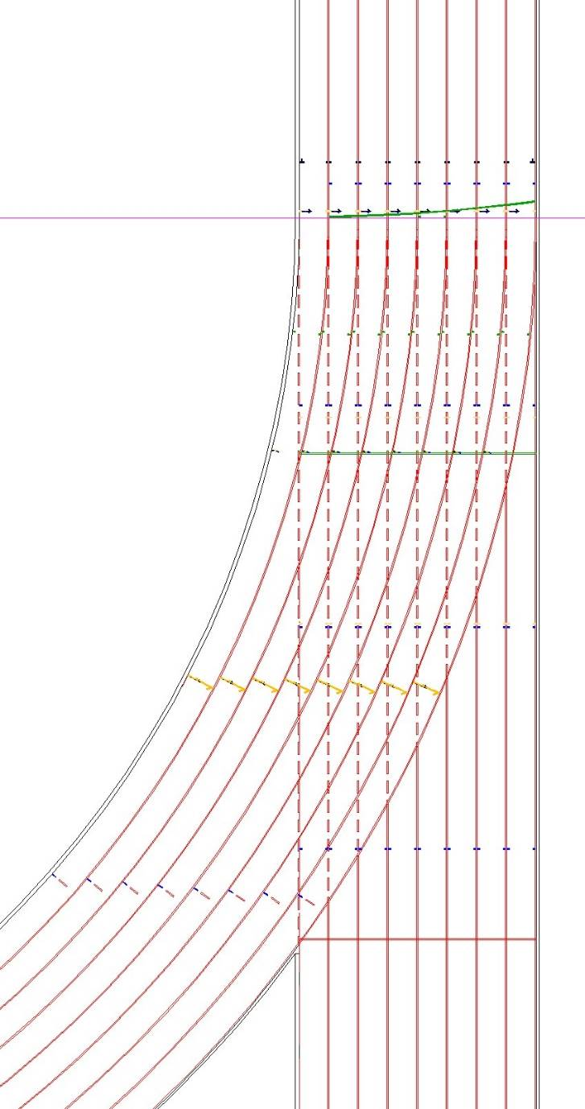

Q3-2 5000m
There are 24 athletes on a split start. You have at your disposal – 1 Duty Starter and 5 others. You must decide who they are and describe their roles.
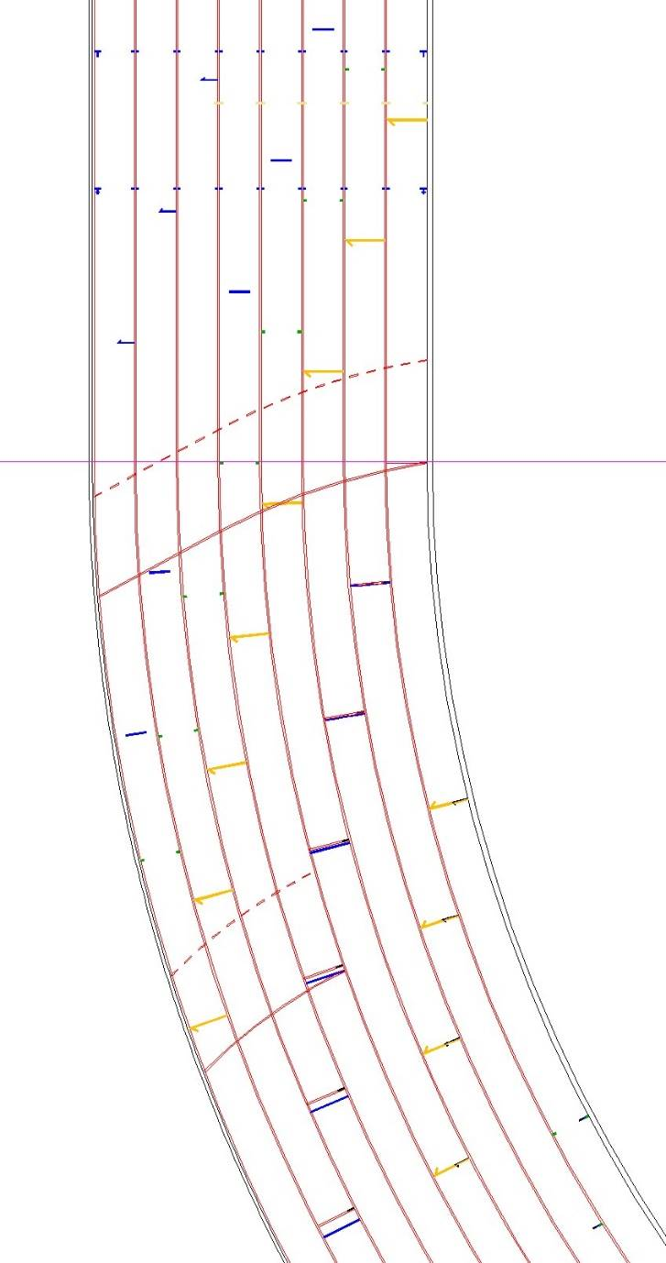
Technology provider’s clock
5000m split start– for question 3. Deploy all staff you think are required

Q4 WPA Events

Q4-1 In a 200m race for Sports Class T62 an athlete comes on to the track and asks to have two sets of blocks placed in his lane.

Q4-1-1 Describe your course of action; your answer should include possible communications with all interested parties. What would be the expected outcome?

Q4-2 A T12 athlete is declared to run with his guide. The athlete reaches the start line without his guide.

Q4-2-1 Describe your course of action, including any card(s) you may issue giving reasons for your decisions.

Q5 Role of the Start Coordinator

Q5-1 Describe two different ways a Start Coordinator can implement his role at National or International level.

Q5-2 Give reasons for which of the above roles in preferred in the UK.

Q6 Role of the Starter

Q6-1 Place the following aspects of a starter’s role in order of importance giving reasons for your choice.

- Starter’s commands, the start sound and any recall signals are heard simultaneously by all.
- The starter is the principal decision maker regarding false starts including occasions when an offence has been committed and the race is recalled by him or any Recall Starters.
- The Starter is positioned so that they have full visual control over all athletes during the start procedure
- The SIS control module is positioned close to the starter
- He personally consults the information produced by the SIS
- All Athletes have a fair start within the rules of the competition
- The starter should listen to the reasons as to why a recall starter stopped the race.
- The Starter is positioned so they can see all Athletes in a similar and narrow angle of vision.
- He uses the SIS information as a resource to assist in determining his decision.

Q7 Zero Control Test

Q7-1 Why is there a need for the Start Referee and Technical Delegate to oversee the Zero Control test?

Q7-2 What is the purpose of the Zero Control test?

Q8 Scenarios for Starter’s Assistants

Q8-1 You are CSA at a Regional/Area League Meeting. Before the start of the meeting there are items apart from your personal equipment you should ensure are available. Name two such items.

Q8-2 At a British League Premier event you are a Starter’s Assistant. You have checked in 7 out of 8 athletes in the women’s 200m. You have given “the board”, the starter has acknowledged and “whistled up”. The missing athlete then arrives, goes to her lane and starts to change her shoes explaining she has just come from High Jump. How would you handle this situation? What might be the possible outcomes and who would make that decision?

Q8-3 At a poorly attended league meeting you are checking in athletes for the Men’s 400m hurdles. Only 4 ‘A’ runners and 2 ‘B’ runners have reported. You feel that it might make sense to combine the heats to make one decent race of 6. Who would you consult? Who would make this decision? How would the lanes be apportioned? What other officials might need to be informed / involved?

Q9 Televised Meetings Starters Assistants

Q9-1 At such events no bags are allowed on the field of play. List, with reasons, what equipment you would have about your person to allow you to function as a starter’s assistant.

Q9-2 You are Chief Starters Assistant at a major event. At the start of the Men’s 4x400m relay the athletes have been checked in by your SA and handed over to the changeover steward. As the first leg athletes assemble behind blocks you hear over radio the changeover steward saying that the last leg runner from the team in lane 3 is missing. The starter gives the command “On your marks”. On your radio you hear the Competition Director querying that all teams are complete. As Chief Starter’s Assistant what course of action, if any, would you take and why? What follow up action(s) would you then take?

Q9-3 At an International event the last race is the Men’s 4x100m. You are assigned to collect the batons at the end of the race. The winning last leg runner crosses the line and celebrates by throwing the baton in the air. Without stopping the athlete continues round the tack on a lap of honour. Describe your actions to handle this situation and what could be the possible outcome.

Q9-4 You are CSA at a major televised meeting. Your team are lining up the ladies for an 800m. In lanes 2 and 4 athletes are “doubled up”. Just before “board up” the athlete in lane 3 decides to withdraw and leaves the track. One of the athletes in lane 2 then moves into the now empty lane 3 expressing the view that it is silly to share if there is no need. How would you deal with this situation? Who would be involved and what might be the outcome?

Q10 Start Referee

Q10-1 Why is it important that the Start Referee, wherever possible, should be a specialist and experienced starter?

Q10-2 After completing a race an athlete approaches you, in role of Start Referee, to verbally protest that the starter and his team failed to recall a false start by the athlete in an adjoining lane. What would be your course of action?

Q11 Reaction Times and SIS Information - Omega
A Women’s 100mH race is recalled and you are Duty Starter.
Q11-1 You are given the readout below.
Q11-1-1-Based on the times shown what would be your decision? Give your reasons. Don’t forget to quote the relevant rule number(s).
Q11-1-2 Who else, if anybody, would need to know the rule invoked?

Q12 Reaction Times and SIS Information – Finish Lynx
A Visually Impaired 100m race and you are Duty Starter, the start was clean in both the duty starter and recall starter’s opinion.
Q12-1 You are given the readout below.
Q11-1-1-Based on the times shown below, do you think any of the athlete’s prejudged when the gun was going to be fired? Give your reasons.
Q11-1-2 Is the start legal?
Q11-1-3 Which visually impaired class competed in this race? Explain your answer.

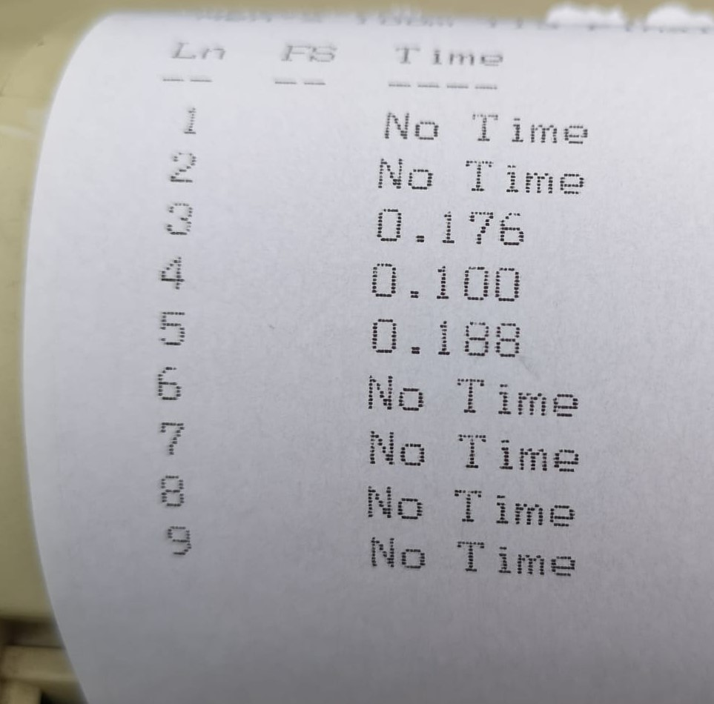

Q13 Using Your Judgement as Start Referee
Q13-1 Watch the video from the WPA European Championships in Swansea. Regardless of what the outcomes were on the track, decide how you would have handled the situation that presented itself in your position as Start Referee.

Video Link: https://www.youtube.com/watch?v=6ku6WRyEV0Q

Q14 Using Your Judgement as Duty Starter

Q14-1 Watch the video from the Paralympic games in Rio and decide what your instant decision would have been regardless of the result in the video. Explain your answer.
Video Link: https://www.youtube.com/watch?v=nFq2MMA-AvA

