Maesgwm Detour: 5th August 2023
Distance: 18.9 km; Climb: 1,060 metres

The weather conditions in the Llanberis area for the Maesgwm Detour, the third race in the 2023 UK Athletics Hill and Fell Running Championship were not as bad as forecast with only light rain and a stiff breeze. Most of the contenders for championship medals were on the start line but a few who had gathered points in the race in Northern Ireland probably decided to save themselves for the final championship race at Sedbergh two weeks later.
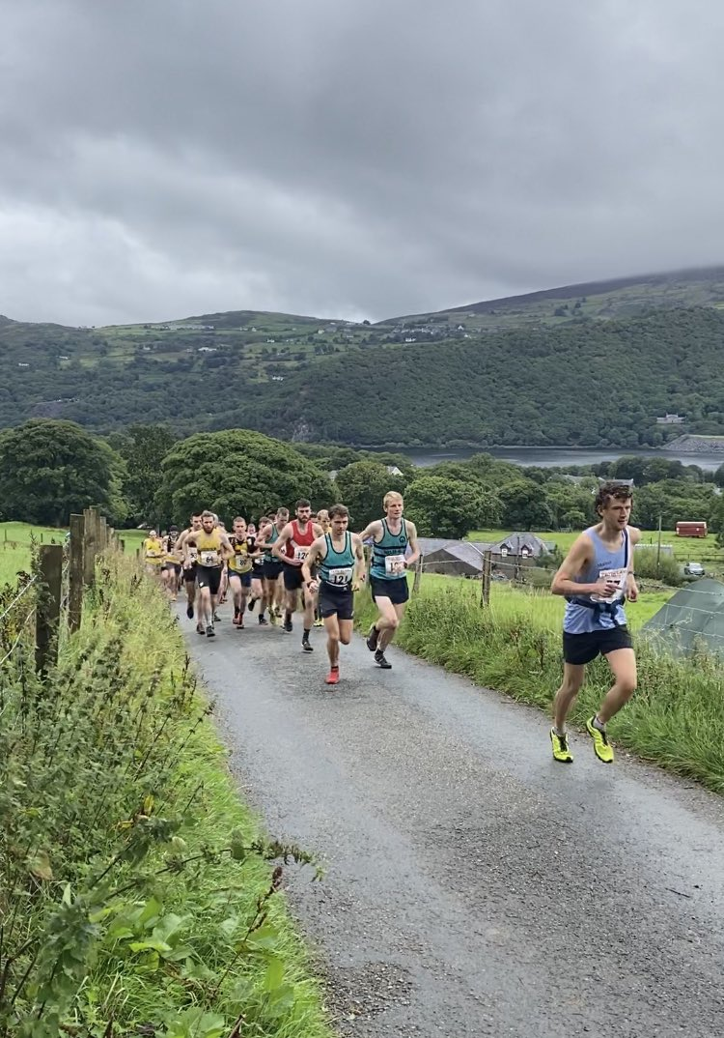
Championship leader, Billy Cartwright (Matlock) set the early pace up the lane, followed by Helm Hill’s Chris Richards and Tim Lamont.. Billy, together with Joe Steward (Salford) who was running in his first British Championship race as part of his preparation for the Sierre-Zinal race, worked together to distance the rest of the field. Joe managed to open a gap in the closing stages of the race to take victory in 1:21:45, thirteen seconds ahead of Billy. Chris Richards took third place in 1:24:48 and is in second place in the championship, only one point adrift of Billy. Third place is held by u23, Finlay Grant (Dark Peak) who missed this race. In Finlay’s absence and that of Ben Sharrock (Ambleside), joint leaders of the u23 category, the leading u23 was Alex Mason (Dark Peak) in 11th place, followed by Ifan Oldfield (Wrexham), seven seconds ahead of Ollie George (Sarn Helen). Alex moved into the u23 bronze medal position behind Finlay and Ben.
The leading v40 man, in eighth place, was the winner of the previous two Championship races, Steven Hebblethwaite (Keswick), followed by Rob Jebb (Helm Hill), with Math Roberts (Calder Valley) in third. Steve and Rob are 1st & 2nd overall followed by Andrew Fallas (Carnethy). In the absence of Karl Gray (Calder Valley) who was the leading v50 in the first two races, Kenny Richmond (Helm Hill) took maximum points ahead of Karl’s club mate, Shaun Godsman with Justin Carter (Cambuslang) in third. The medal positions, Karl, Kenny, and Shaun are unchanged. As at Melantee, Colin Donnelly (Cambuslang) led the over 60s, ahead of Paul Cornforth (Ambleside). Behind, Paul, Adrian Davis (Lomond Hill Runners) and David Griffin (Helm Hill), who were tied for second in the standings after the Scottish race, were separated by only five seconds and dropped to fourth & fifth place overall behind Colin, Stewart Whitlie (Carnethy) and Paul.
In the female championship, Nichola Jackson (Keswick) made it three wins out of three, finishing in 24th position in a time of 1:35:46. Sara Willhoit (Mercia) was second in 1:37:04, just thirteen seconds ahead of Eve Pannone (Eden); Sarah and Eve are currently in the silver and bronze medal positions whilst Eve as leading u23 took over the lead in that category. Alice Gamble (Sheffield University) was the only other u23 in the field and is in the silver medal position. Sharon Taylor (Helm Hill) was first v40 and took over the lead in that category; second v40 was Joanne Henderson (Denbigh Harriers), ahead of v50s Mel Price (Mercia) and Lou Osborn (Ambleside) who are in the v40 silver and bronze medal positions as well as the leading the v50s ahead of Rhian Probert (Mynydd Du) who finished the race only seven second behind Lou.
Keswick have still got work to if they want a sixth consecutive male team title after finishing behind Helm Hill; going into the final championship race, Keswick are only one point ahead of Carnethy with Helm Hill two points further back. A third-place finish for Dark Peak kept them in contention for medals. Helm Hill, Calder Valley, and Mercia filled the first three places in both the Male v40 and v50 teams; Helm Hill lead the v40 standings ahead of Calder Valley with Dark Peak in third whist in the v5os, Calder Valley retained their lead over Helm Hill.
Victories for Mercia in the female and female v40 teams resulted in them taking over the lead in both championships; Helm Hill were second Female team but are still outside the medal positions behind Ambleside and Carnethy; however third place for their Female v40 team, behind Denbigh put them in second place in the overall standings.
On behalf of the British Athletics Mountain Running Advisory Group Sub-Committee (MRAG), I would like to thank Mike Blake and members of Eryri Harriers for their excellent organisation. Photos courtesy of Duncan Richards & Arwel Lewis.

